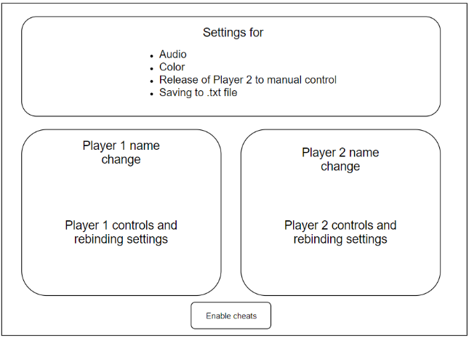Final project proposal

Qt has been installed and is functional.

Teammate- Trinh Lang ([trinhlang25@gmail.com](mailto:trinhlang25@gmail.com))

Project proposal- Pong++

When launched, open to menu with 3 buttons- “Settings”, “Instructions”, and “Play”. (see bottom image for XML diagram)

1. Settings (top image)
   1. Standard menu screen, allows rebinding of keys to desired format
   2. 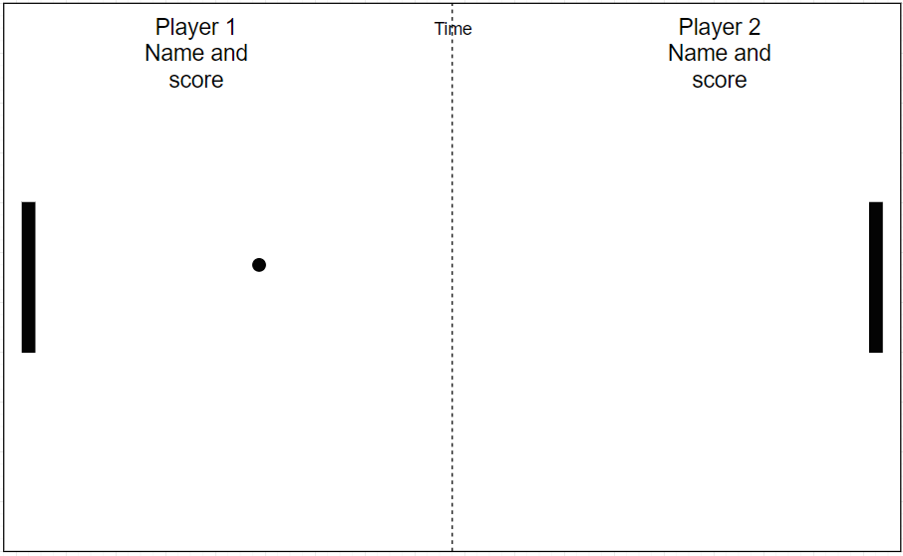Releases player 2 from CPU to allow for 2nd player
   3. Allows for changing of colors
   4. Allows manipulation of audio
   5. Allows changing of team names
   6. Allows for saving of score to file
   7. Custom points needed to win and
2. Instructions (2nd image)
   1. Shows field and default control scheme
   2. Bottom display displays rules of pong
3. Play (2nd to bottom img)
   1. 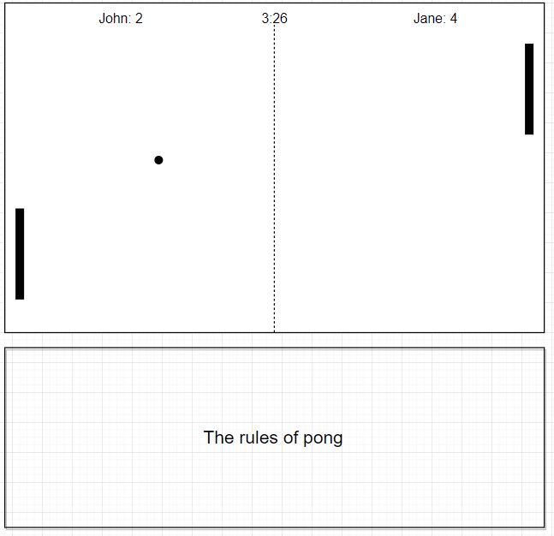Takes player to top-down display of field
   2. Player 1 controls bottom field, player 2 controls top field
      1. Top of screen is taken up by timer and point counter
   3. Computer player AI will attempt to predict where the ball is going and move accordingly
      1. May implement feature that allows for toggling of difficulty
   4. Ball will move faster the longer it is into a round

Schedule:

Week 1- Conceive ideas/Install QT

Week 2- Start coding/play around with QT

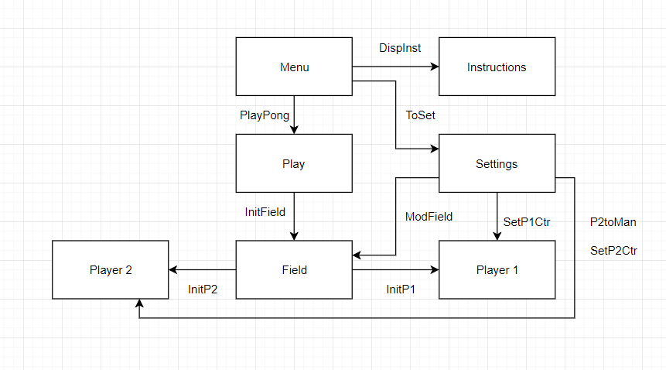Week 3- Code field

Week 4- Code P1 controls and menu/functions

Week 5- Code instructions and settings

Week 6- Code P2 options and computer-controlled player

Week 7- Finish computer player

Week 8- Testing/documentation preparation

Week 9- Presentation preparation/Final touches/Last-minute testing

Week 10- Presentation

"I pledge that I have neither given nor received unauthorized assistance on this assignment."